**Sardar Patel Institute of Technology**

**(Computer Engineering Department)**



**Internet of Things Lab (OE4)**

**Project Report on**

**ECG Monitoring**

**Name:** Shivam Pawar

**UID:** 2019230068

**Name:** Vishal Salvi

**UID:** 2019230069

**Class:** TE Comps

**IOT Lab Batch:** B

**NAME: Shivam Pawar UID: 2019230068**

**NAME: Vishal Salvi UID: 2019230069**

**CLASS: TE COMPS BATCH: B**

**Project Report**

**Project Title: ECG Monitoring**

**Introduction:**

Heart diseases are becoming a big issue for the last few decades and many people die because of certain health problems. Therefore, heart disease cannot be taken lightly. So there should be a technology that can monitor the heart rate and heart behavior of the patient regularly. By analyzing or monitoring the **ECG signal** at the initial stage the various heart disease can be prevented.

This is the reason why I am presenting you with this great **IoT project**. In this project, we show you how you can **interface AD8232 ECG Sensor with NodeMCU ESP8266** Board and monitor the **ECG Waveform** on Serial Plotter Screen. Similarly, you can send the ECG waveform over the IoT Cloud platform and monitor the signal online from any part of the world using the PC or simply using the Smartphone. There is no need for staying in the Hospital to monitor heart activity/behavior just because you can monitor it online from anywhere. Thus, it can be said advancement in **Patient Health Monitoring System.**

**AD8232 ECG Sensor**

This sensor is a cost-effective board used to measure the electrical activity of the heart. This electrical activity can be charted as an ECG or Electrocardiogram and output as an analog reading. ECGs can be extremely noisy, the AD8232 Single Lead Heart Rate Monitor acts as an op-amp to help obtain a clear signal from the PR and QT Intervals easily.

[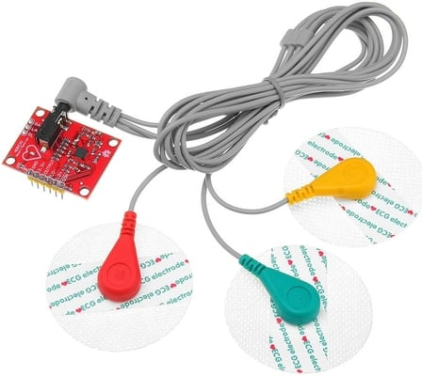](https://how2electronics.com/wp-content/uploads/2020/03/AD8232-ECG-Sensor.jpg)

The AD8232 is an integrated signal conditioning block for ECG and other biopotential measurement applications. It is designed to extract, amplify, and filter small biopotential signals in the presence of noisy conditions, such as those created by motion or remote electrode placement.

The AD8232 module breaks out nine connections from the IC that you can solder pins, wires, or other connectors to. SDN, LO+, LO-, OUTPUT, 3.3V, GND provide essential pins for operating this monitor with an Arduino or other development board. Also provided on this board are RA (Right Arm), LA (Left Arm), and RL (Right Leg) pins to attach and use your own custom sensors. Additionally, there is an LED indicator light that will pulsate to the rhythm of a heartbeat.

**Circuit Diagram:**

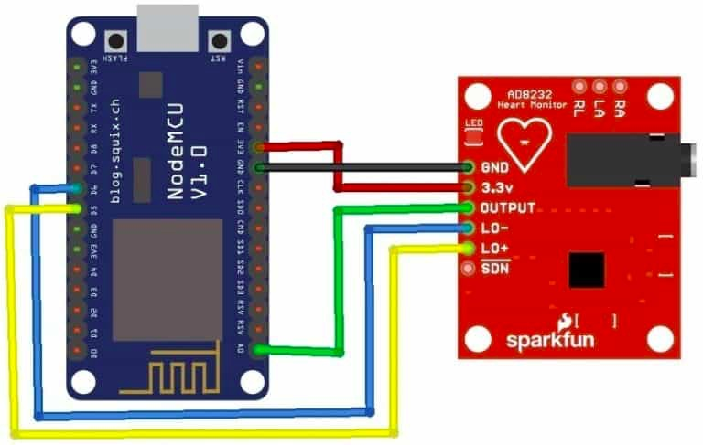

**Code:**

#include <ESP8266WiFi.h>

#include <Wire.h>

#define WIFI_SSID "AndroidSP21"

#define WIFI_PASSWORD "11223344"

void setup()

{

// initialize the serial communication:

Serial.begin(9600);

WiFi.begin(WIFI_SSID, WIFI_PASSWORD);

Serial.print("Connecting");

while (WiFi.status() != WL_CONNECTED) {

Serial.print(".");

delay(500);

}

Serial.println();

Serial.print("Connected with IP: ");

Serial.println(WiFi.localIP());

pinMode(D5, INPUT); // Setup for leads off detection LO +

pinMode(D6, INPUT); // Setup for leads off detection LO -

}

void loop() {

if((digitalRead(10) == 1)||(digitalRead(11) == 1)){

Serial.println('!');

}

else{

// send the value of analog input 0:

Serial.println(analogRead(A0));

}

//Wait for a bit to keep serial data from saturating

delay(1);

}

**Output:**

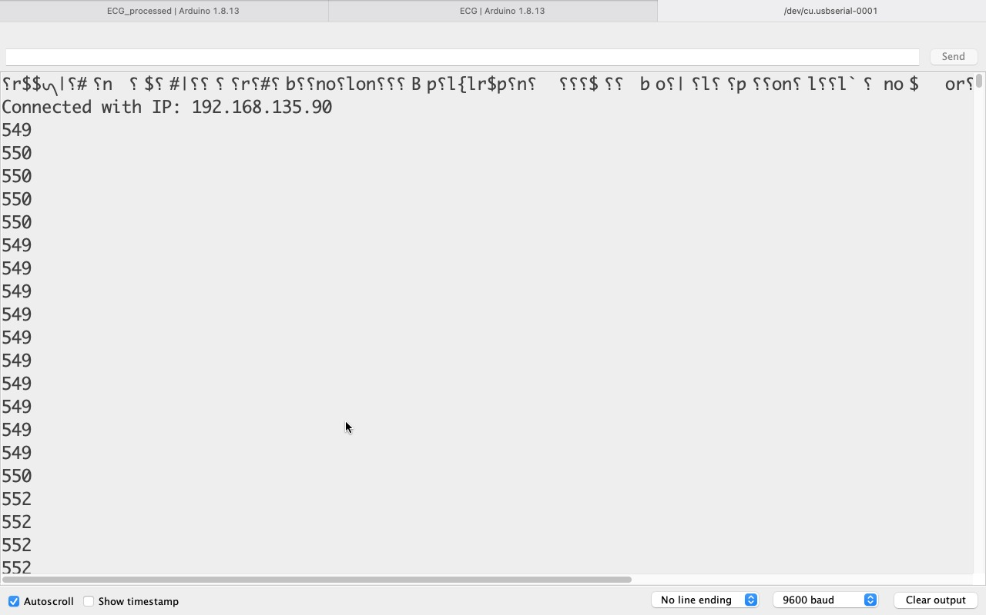

**ECG Signal:**

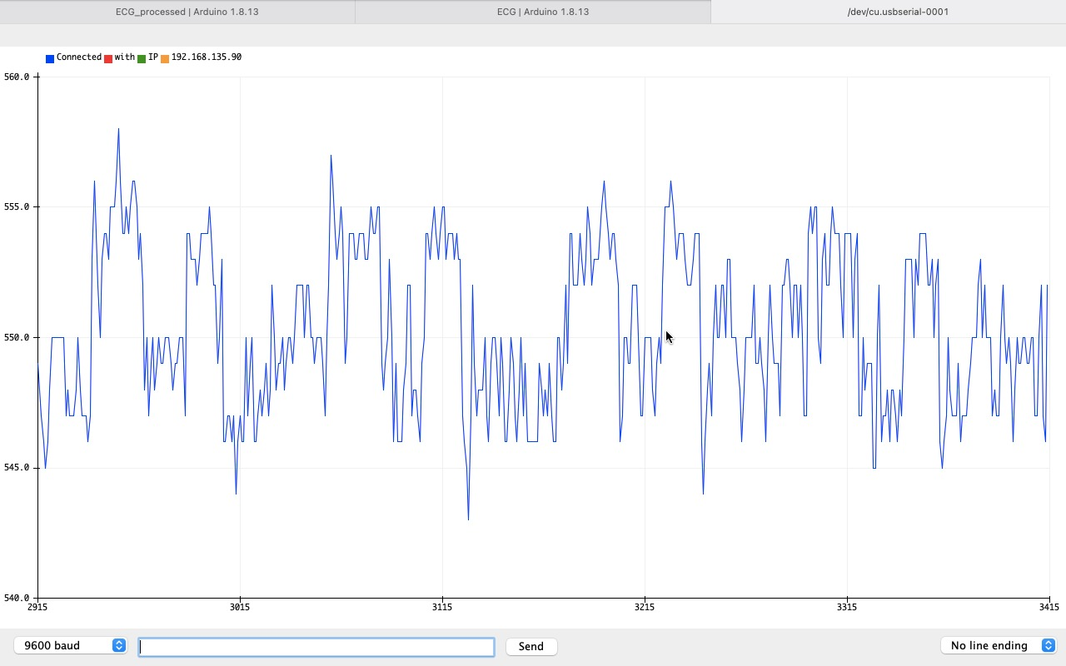

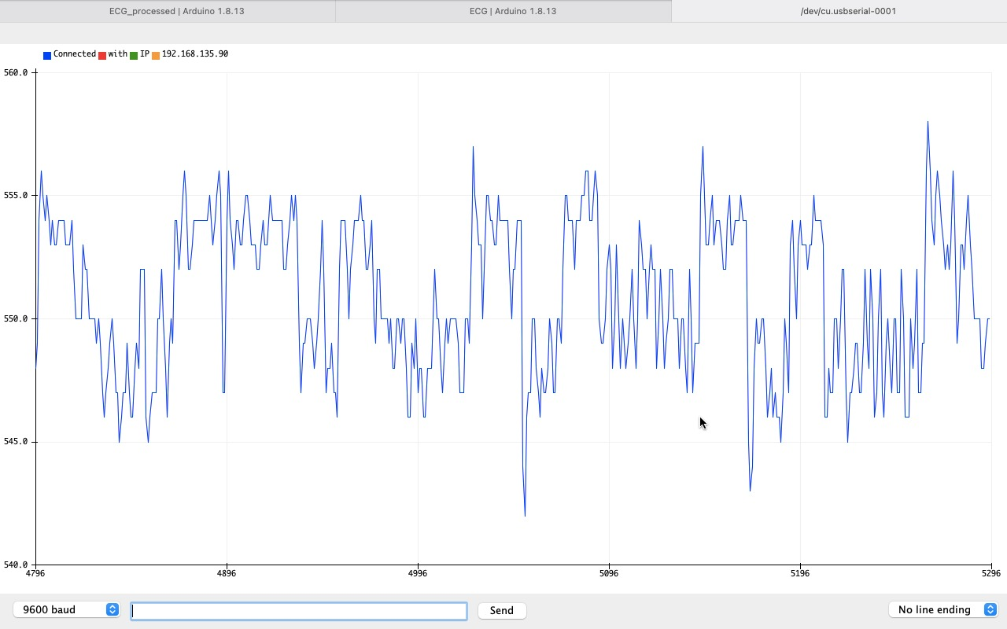

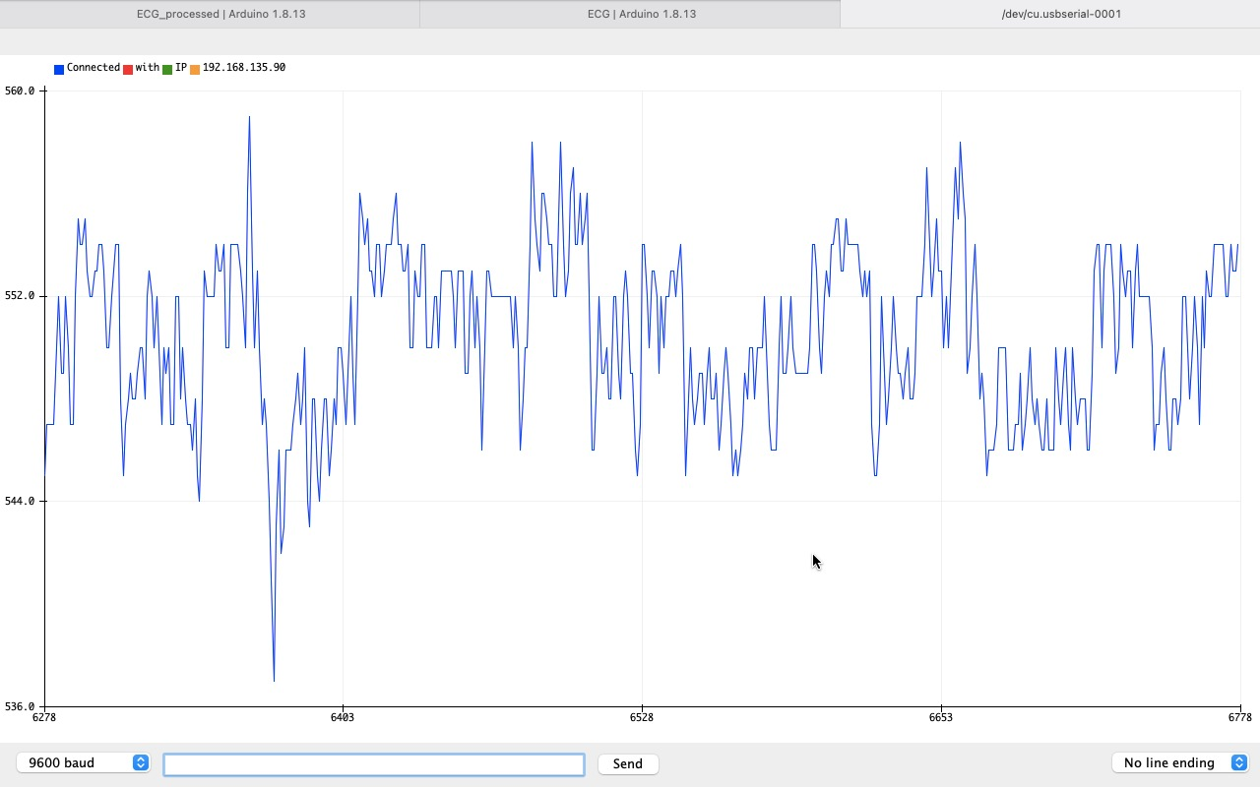

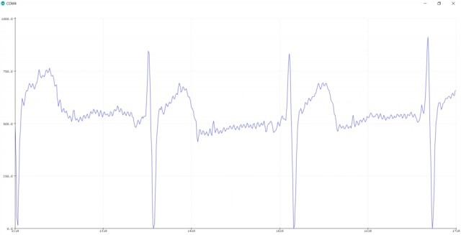

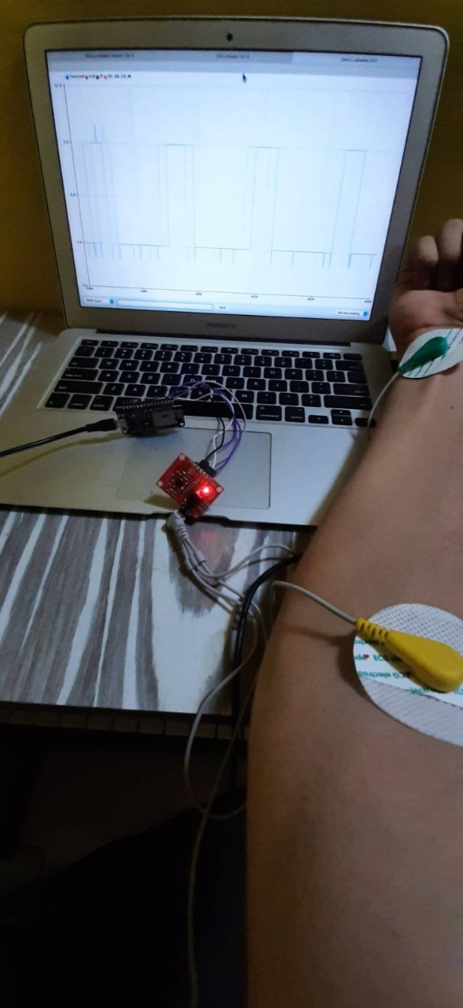

**Result:**

Electrocardiogram (ECG) is an important biological and pathological signal; it is widely used for ambulatory monitoring and diagnosis of heart diseases. It is acquired by placing electrodes at several positions on human body that generate huge amount of data during monitoring and recording of the signal due to multiple channels and sampling rate.

**Conclusion:**

Thus, from this project we implemented patient ECG data and monitor the ECG Signal. Also studied more about heart rate as well as ECG Signals. ECG signal compression is an important part of health care system to make treatment economical due to several advantages as less consumption of storage space, transmission over lower bandwidth communication system.